Alan D Horn 515733
Photography 3
Contextual Studies
Assignment 2 Literature Review

Coastal Erosion in Happisburgh, East Norfolk

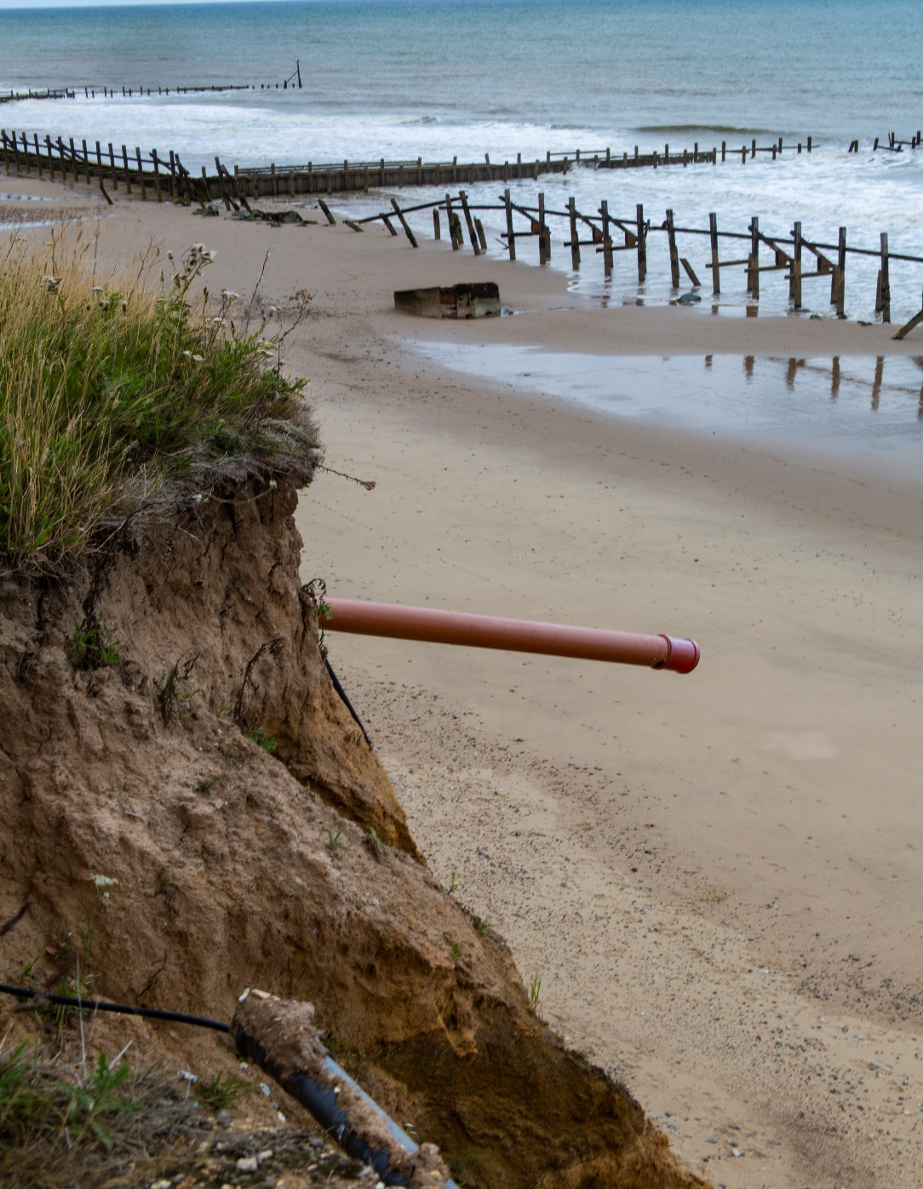
Happisburgh August 2019 Alan D Horn

Introduction
Historical coastal erosion in east Norfolk is well documented but its acceleration suggests that fundamental changes to the landscape and communities are inevitable and, in many cases dramatic.
The real conundrum is what can be done and over what period of time to protect communities or develop strategies to manage the upheaval and changes needed.
These issues also need to take into account the oft quoted measure of cost-benefit analysis that controls Government thinking and spending on coastal erosion versus flood protection.
Climate change scenarios also affect the decision-making processes – and in most cases make the outlook for affected communities even bleaker.
My focus is on the area around Happisburgh (pronounced hayz-br-ugh) a small village with a population of around 1400 where erosion of its cliff face has already led to streets and homes being consumed by the North Sea.
In 2013 the advancing erosion uncovered what are thought to be the earliest human footprints outside Africa. (Ashton, N, et al 2014 Hominin footprints from early Pleistocene deposits at Happisburgh,UK. PLoS ONE)
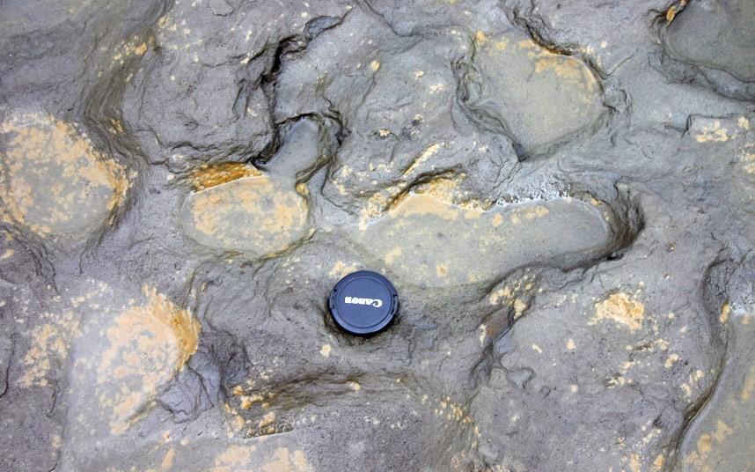
Eastern Daily News

A village that may be the oldest known settlement in Europe, clearly of significant historical value is falling into the sea.

The literature review will seek to address a number of questions -
1 What are the causes?
2 What is the extent of the damage?
3 What is the current position?
4 What is the future for Happisburgh?

1. What are the causes?
The British Geological Society (BGS) have produced a series of papers regarding coastal erosion. Relevant to the area around Happisburgh is Catherine Poulton's Disappearing Coasts (2004) with its stark introduction – "England has some of the fastest retreating coastlines in Europe. Along some coasts in the south and east, the cliffs are made up of soft sediments that are easily eroded. Whole villages have been lost to the sea over the years and many more may be on the brink of joining them"

The BGS studies focus on Happisburgh and examine two key factors. The first is the make-up of the cliff materials in terms of its geological composition and positioning. In Happisburgh, the cliffs are made up of a contorted mix of sands, gravels, silts and clays which are highly variable, weak and easily eroded. Secondly, whilst Happisburgh's coastline was not defended until 1959, about 70% of the Norfolk Coast was defended and these factors have had a detrimental effect on the Happisburgh erosion rates by reducing the sediments arriving from updrift.

BGS produced a more detailed survey in 2006, Preliminary investigation into monitoring coastal erosion using terrestrial laser scanning at Happisburg, Norfolk pp 45-64. The study quotes: "One of the critical factors affecting the rate of erosion is determined by the transport of sediments away from the source- that is, from the cliffs"…..…."test sites in the past have not been defended or not maintained, or have failed e.g. Happisburgh"……." The future predictions of sea level rise and storm frequency due to global warming are likely to have a profound impact on the erosion rate at Happisburgh".
Between 1992 and 2004 only some sea defences were in place and where they had failed or been removed the damage was measurable in a cliff line retreat of 105metres.

The final survey by BGS Slope Dynamics Project Report: Norfolk Coast 2000-2006 pp20-47 which was reproduced in precis form in 2019 as a case study: Coastal Erosion at Happisburgh, Norfolk, concluded that "Rapid erosion of the cliffs at Happisburgh means that we can observe processes that for other sites may take thousands of years".

It is fair to say that the survey work by BGS is focussed on the causes of the landslides which is good for scientific analysis but not necessarily for Happisburgh as BGS offer no solutions to the rapid cliff retreat and its effect on the community.
The Committee on Climate Change (CCC) 21 Jan 2014, Flood and coastal erosion risk management spending p4 concurs with BGS on the issues of the defence failures being a major factor in the Happisburgh cliff erosion but also highlights that the defences of towns further up the coast "have significantly affected the rate of cliff erosion in Happisburgh".

2. What is the extent of the damage?

Map1 shows the retreat from (estimated) 1885 through 2006 (BGS)

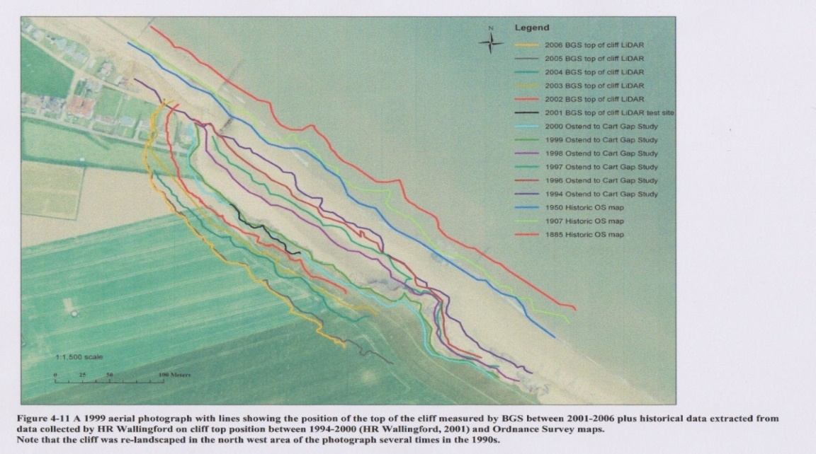

Map 2 shows the retreat from 2000 to March 2019 (NNDC)
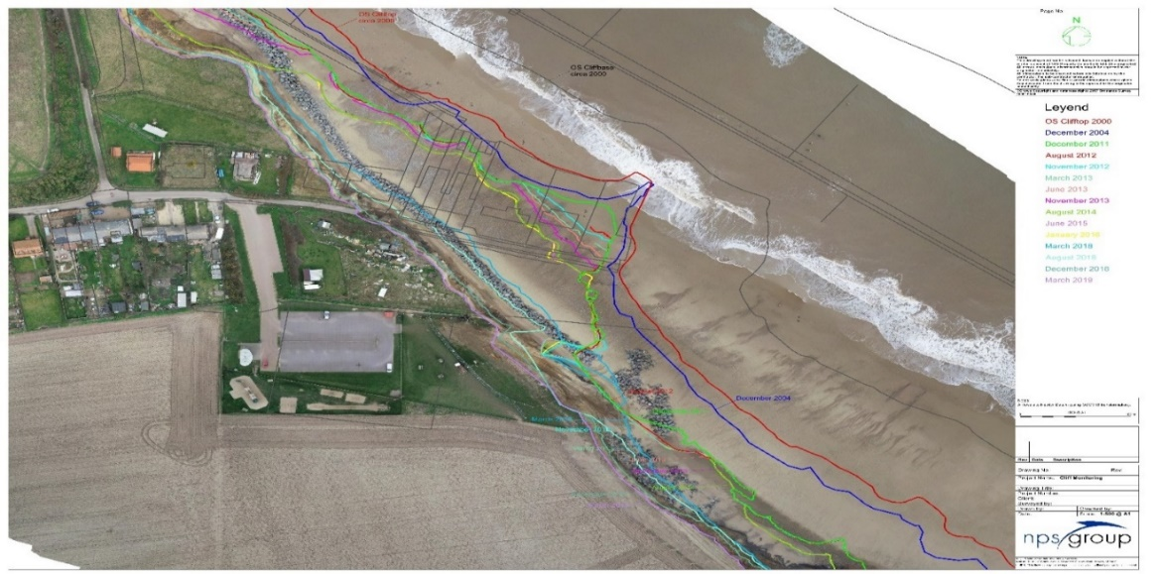

A more graphic illustration comes from the archives of Mike Page (Mike Page Aerial Photography) who has given me permission to use his images of Happisburgh from his website – www.mike-page.co.uk
The site is very comprehensive but I have selected four images to illustrate the dynamics of the erosion from 1996………

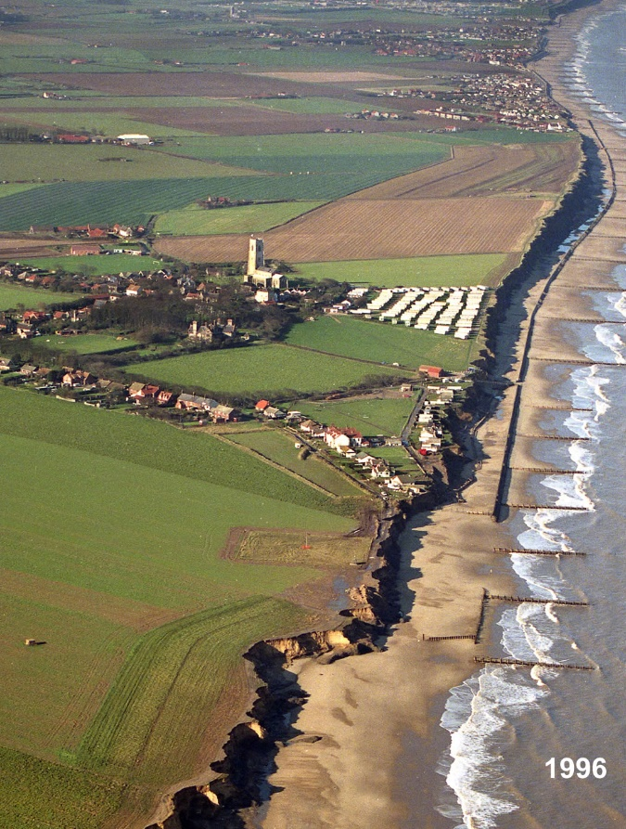

….through 2006…..

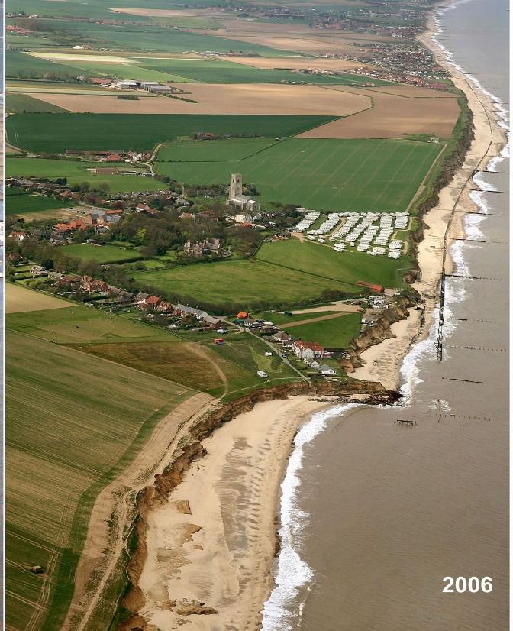

…..to 2012

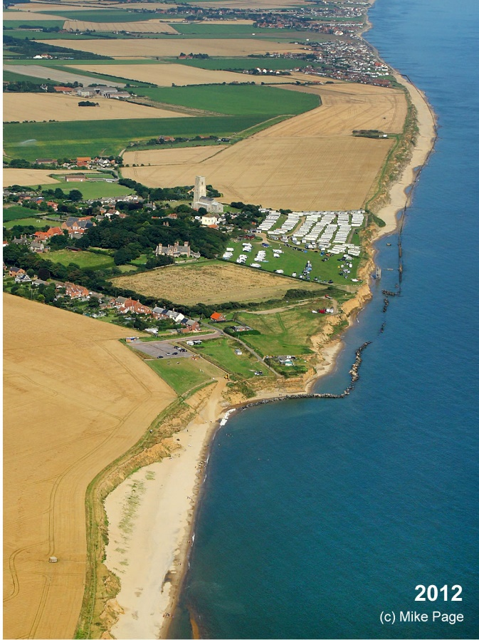

….to 2019

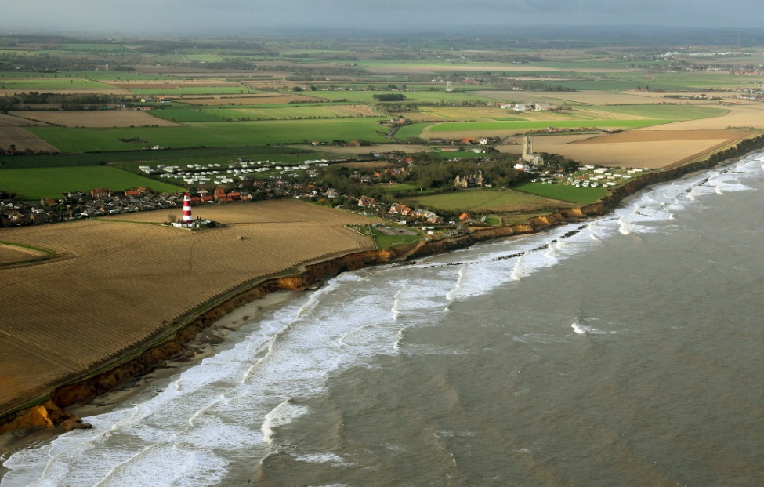

Beach Road has gone. All the properties on it have gone. The shoreline protection has gone and today, 2019, the caravan park is no more.
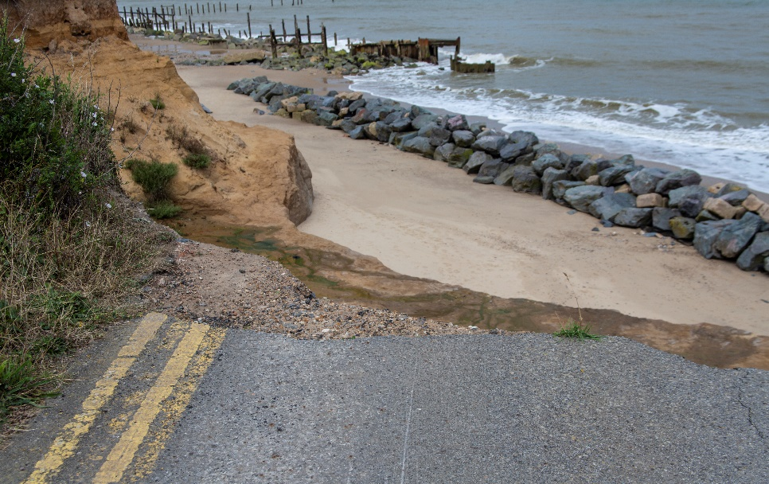
Happisburgh August 2019 Alan D Horn

3 What is being done to protect the land and community?

The answer is a very limited amount and if government estimates on the seriousness of homes at threat to coastal erosion are to be believed the issue is not high on their agenda.
The Environment Agency (EA) Managing flood and coastal erosion in England: 1 April 2011-31 March 2017 published in March 2018, estimated that 6.2 million English homes are at risk of flooding compared to just 700 homes at risk from coastal erosion over the next 20 years – the latter seemingly a very minor concern in comparison to flood risk. However, the figures assume "interventions" and without these, the EA accepts, that the homes lost to coastal erosion over the next 50 years will reach at least 28,000 - the equivalent of a medium sized town.
However, the CCC believe this figure to be at least 5000 homes in 2018 rising to 32,000 within 30 years (Ben Webster's Coastal Homes "must be sacrificed to the sea", published in the Times on 10 September 2019).
The EA figures are even more difficult to understand when examining the East Anglian Coastal Group projections map, albeit produced in 2009 but clearly part funded by the EA. It shows (Map 3) that between Bacton and Happisburgh, a distance of a few miles, the projected erosion rates will swallow many more homes than the whole of EA's 700 England wide estimate.

Map 3 Projections from 2009 through 25, 50 and 100 years versus holding the defence
Source – East Anglian Coastal Group

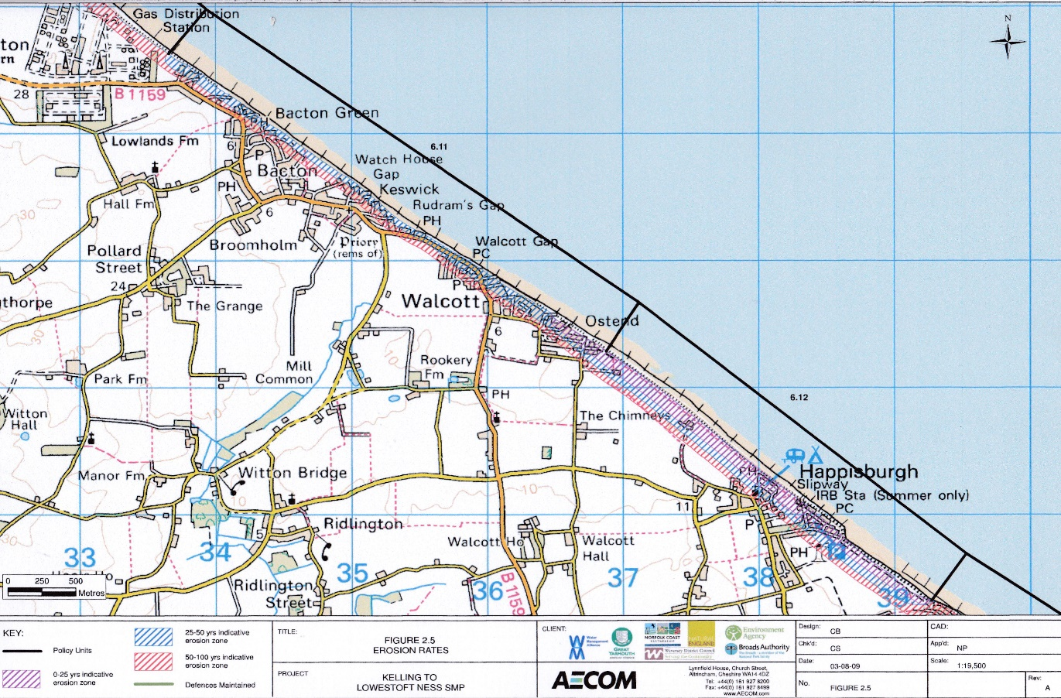

It is hard to reason with the monumental difference of opinion between the EA estimates of homes lost to the sea through coastal erosion and those of the CCC. There can be little doubt that available funding is the real issue.

EA's Long-term investment scenarios (LTIS) 2019, published in May 2019, focusses on the long-term investment needs for Flood and Coastal Erosion Risk Management (FCERM) in England in the areas of asset deterioration, climate change and a growing population. Since the last analysis in 2014 the LTIS is estimating that the investment required to successfully manage a "high climate change" scenario is much higher now than 5 years ago and that an annual expenditure of £1bn is needed. However, in the event of "an extreme climate change" scenario, "there are more places where new investment is not cost effective".
The EA numbers do not stack up with the DeFRA paper Central Government Funding for Flood and Coastal Erosion Risk Management in England Sept 2019, p4, that confirms allocation of £815m (a shortfall of £200m) for 2019/20 but has only confirmed £469m (to date) for 2020/21 (a shortfall of >£500m).
Two Government papers published in 2019 that are contradictory and funding falling far short of EA's estimated needs.

3. What is the current position?

Brian Farrow, Coastal Engineer for North Norfolk District Council (NNDC) has been very helpful and focussed me on to a number of NNDC papers on Norfolk's Shoreline Management Plans (SMPs).
Introduction to Coastal Management 2019 is clear about the seriousness of the area between East Cromer to Cart Gap, Happisburgh - "Over time, houses, businesses and communities will become more affected if sea defences are not in place and a way forward for managing a changing coastline will be required"
"Funding for coastal management from central government is limited and highly competitive. Currently there is no dedicated source of funds to assist communities adapt to coastal change, however such schemes are vital if we are to manage the coast".
This is an admission that funding is the major issue.

NNDC's 2019 Coastal Protection paper spells out the cost of the various forms of coastal protection, covering Seawalls, Groynes that physically stop longshore sediment transport, Revetments, sloping timber structures, gabions, large metal wire cages filled with rocks, Rock Armour, dissipates wave energy and now in place on part of Happisburgh beach and Renourishment, also known as sandscaping, adding large quantities of sand/shingle to a beach. The report concludes that all of the options are expensive to install and difficult/costly to maintain. Furthermore, the cliffs at Happisburgh are up to 10 metres high, exacerbating the problem of cost.

NNDC's Coastal Adaptation at Happisburgh 2019 opens with a clear statement – "Coastal policy in
recent years has changed from "Hold the Line" to "Managed Realignment". This means that the coast line protection will be scaled down but effort will be made to manage the erosion. It is clear that Adaptation is "not the most attractive option to local communities" and "the community at Happisburgh worked with NNDC to jointly fund a temporary rock sea defence to control erosion rates in order to buy time for adaptation measures to be developed"
This is a frightening scenario for the community – The community has itself partly funded the rock sea defences whilst measures are put in place but the measures are not even developed for whatever the Adaptation criteria will be.

Adding more confusion is the Sayers & Partners report in October 2018 – GIS based assessment of coastal flood and erosion risk focussing on coastal erosion in England on behalf of the Committee on Climate Change, UK pp8-13. The report examines the Shoreline Management Plan (SMP) for the area around Happisburgh over 3 epochs and analyses the effects on communities through No Active Intervention (NAI) versus the SMP. The figures show that between 2005-2025 there is little difference between either measure of a loss of between 50-80 homes but between 2025-2050 the difference is the loss of circa 500 homes through the SMP compared to circa 800 through NAI.
Furthermore, the cost-benefit analysis shows that implementing the SMP would have a positive contribution over expenditure of over £100,000.

What must be frustrating for Happisburgh residents is the fact that, just 3 miles up the coast from Happisburgh is the gas terminal of Bacton where renourishment (or sandscaping) is being successfully deployed to protect the site and surrounding homes. A recent press article by Ben Webster in the Times -"Sandscaping" offers a grain of hope to coastal homes, published 5 August 2019. The cost of £19m has a contribution of £5m from the EA and £0.5m from NNDC with gas companies led by Shell funding circa 75%. (Also covered by BBC Look East Inside Out 12 September 2019 Presenter, David Whitely)
However, the real issue here is that a gas terminal has to be protected and the coastal homes that are being reprieved by the rebuilding of the beach defences are coincidental. The chair of Walcott Parish Council, Pauline Porter said, "If the terminal wasn't there, the sandscaping wouldn't be happening because our homes don't stack up in the cost-benefit analysis"

4. What is the future for Happisburgh?

The seriousness of the overall problem is exacerbated by lack of clarity between the Government departments of EA and DeFRA as well as CCC on both the size of the problem and funding requirements for England.
NNDC has accepted that it is in a fight for any funding to protect Happisburgh and there is no clarity regarding any funds to assist the community to adapt.
BGS comments in 2006 Preliminary Investigation into Monitoring coastal erosion: Case Study at Happisburgh, Norfolk "The consequences to life, assets and the environment can be enormous – especially as owners do not usually receive any form of compensation for the loss of their homes and livelihoods".
Local people feel helpless and press articles on their fate are worldwide. Michael Savage's article in The Independent, August 2008 The Norfolk Village being swallowed by the sea quoted comments from the residents of Beach Road where properties thought to be valued at £80,000 were considered completely worthless by the banks. Beach Road is no more.
The Geographical's article by Tom Hart, Feb 2015 Norfolk's Disappearing Village comments that the village had receded 50yds over the past decade and that the church, now 200yds from the sea used to be 1 mile away.
The international publication PRI's The World carried an article by Carolyn Beeler April 5 2018, As a British village crumbles into the sea, a family hold on to a home that cannot be saved.
Tom Bristow's 10 July 2018 Article in the Eastern Daily Press entitled "We aren't being looked after" makes an emotional yet pertinent comment – "Humans have roamed the land at Happisburgh for one million years but they are now on the retreat from the oldest settlement in Europe"…. "This stretch of coast is being allowed to erode under government policy called Managed Realignment"

The Happisburgh Village Website which details the history surrounding the increasing destruction of the village from 1959 when timber defences were constructed but lasted less than 30 years. The diary of events focusses on many attempts to address the problem, which were all dropped due to varying reasons from technical to cost to "red tape" surrounding its failing to score enough cost-benefit "points" for DeFRA consideration. Despite the website being live, the last entry was in 2014 covering news on a new toilet block in the "new" car park and that the Manor Caravan Park had been moved inland. Both the original toilet block and car park are now under the sea and the original caravan park is going the same way.

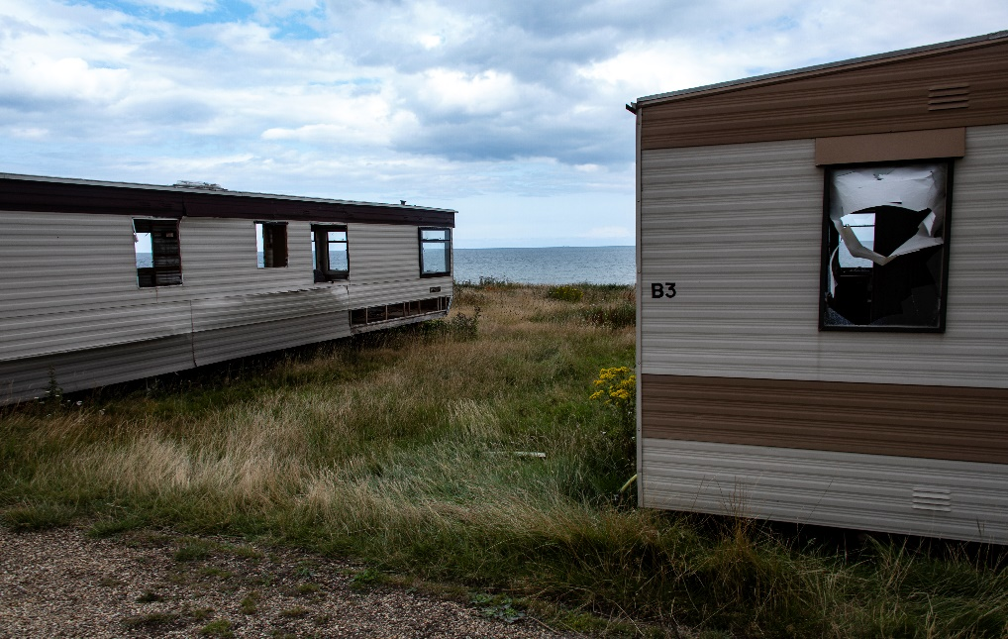
Happisburgh August 2019 Alan D Horn

Word Count, excluding quotes 1977

Bibliography
Environment Agency 8 May 2018 Long Term Investment Scenarios (LTIS) 2019
Environment Agency 23 October 2018 (updated) Coastal Erosion and Shoreline Management
Sayers and Partners LLP October 2018 GIS-based assessment of coastal flood and erosion risk in England on behalf of The Committee on Climate Change, UK The Committee on Climate Change pp8-13
Committee on Climate Change 21 Jan 2014 Flood and coastal erosion risk management spending
Department for Environment, Food and Rural Affairs Sept 2019 Central Government funding for Flood and Coastal Erosion Risk Management in England
Environment Agency 27 March 2018 Managing flood and coastal erosion risks in England 1 April 2011 – 31 March 2017
North Norfolk District Council April 2009 Development and Coastal Erosion
North Norfolk District Council 2012 Shoreline Management Plan 6
North Norfolk District Council 2019 Coastal Protection
North Norfolk District Council 2019 Coastal Adaptation at Happisburgh Case Study
North Norfolk District Council 2019 Tides, Waves and Climate Change
North Norfolk District Council 2019 Introduction to Coastal Management
Farrow, B.J., Coastal Engineer, North Norfolk District Council March 2019 Cliff Monitoring Images
East Anglian Coastal Group c/o Great Yarmouth, Broads Authority, Norfolk Coast Waveney District, Environment Agency
Poulton (now Pennington), C V L. 2004. Disappearing Coasts, Planet Earth, Volume Summer 2004, 26-27.
Poulton (now Pennington), CVL, Lee, J R, Jones, LD, Hobbs, PRN, and Hall, M. 2006. Preliminary investigation into monitoring coastal erosion using terrestrial laser scanning: case study at Happisburgh, Norfolk, UK: Bulletin of the Geological Survey of Norfolk, 56, pp45-65.
Hobbs, PRN, Pennington, CVL, Pearson, SG, Jones, LD, Foster, C, Lee, JR, Gibson, A 2008 Slope Dynamics Project Report: Norfolk Coast (2000-2006), British Geological Survey Open Report OR/08/18 pp20-47
British Geological Survey Coastal erosion at Happisburgh, Norfolk 2019 Case Study
www.mike-page.co.uk Images of Happisburgh from the air covering 2000 to 2019
Webster, B 5 August 2019, "Sandscaping" offers grain of hope to coastal homes" Environment Editor The Times
Webster, B 10 September 2019, Coastal homes "must be sacrificed to the sea" Environment Editor, The Times
BBC Look East Inside Out 12 September 2019 Presenter, David Whitely
2014 Happisburgh Village Website
Bale, D 22 March 2018 "Who knows what will happen?" Norfolk communities under threat talk about fears North Norfolk News
O'Connor, J 21 September 2019 A weekend on the east Norfolk coast The Times
Sunday Times August 2019 Best Beaches in UK Sea Palling, Norfolk
Beeler, C April 5th 2018, A British Village crumbles into the sea……PRI's The World
Hart, T 12 February 2015, Norfolk's disappearing village Geographical
Bristow, T 10 July 2018 "We aren't being looked after" – Norfolk's coast is retreating faster than feared Eastern Daily Press
Savage, M 18 Aug 2008 The Norfolk Village being swallowed by the sea Independent
Ashton, N, Lewis, SG, De Groote, I, Duffy, SM, Bates, M Bates, R et al 2014 Hominin footprints from early Pleistocene deposits at Happisburgh,UK. PLoS ONE

Word Count 2852
Quotes 355
Bibliography 480

